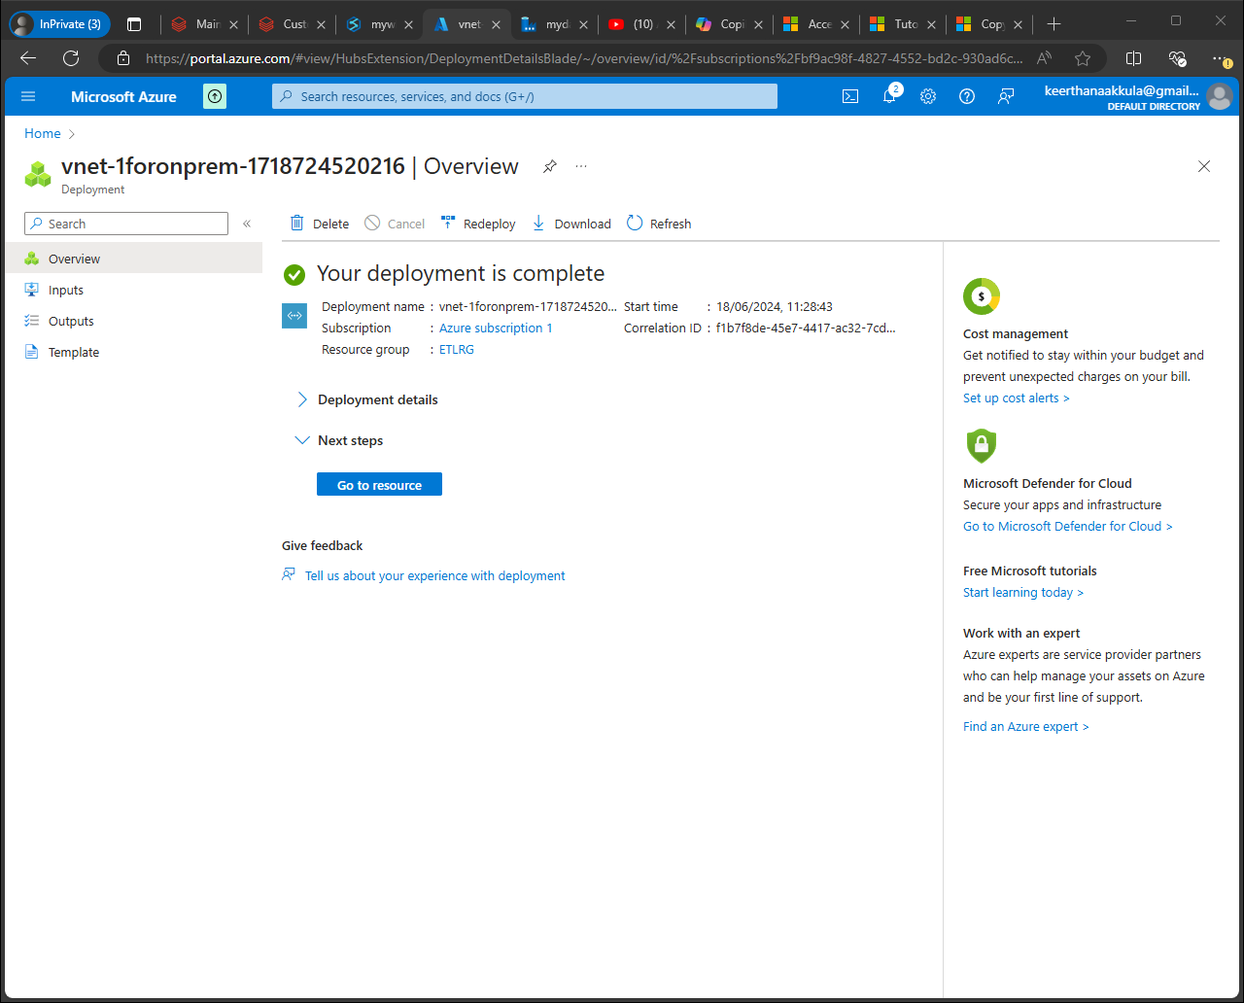

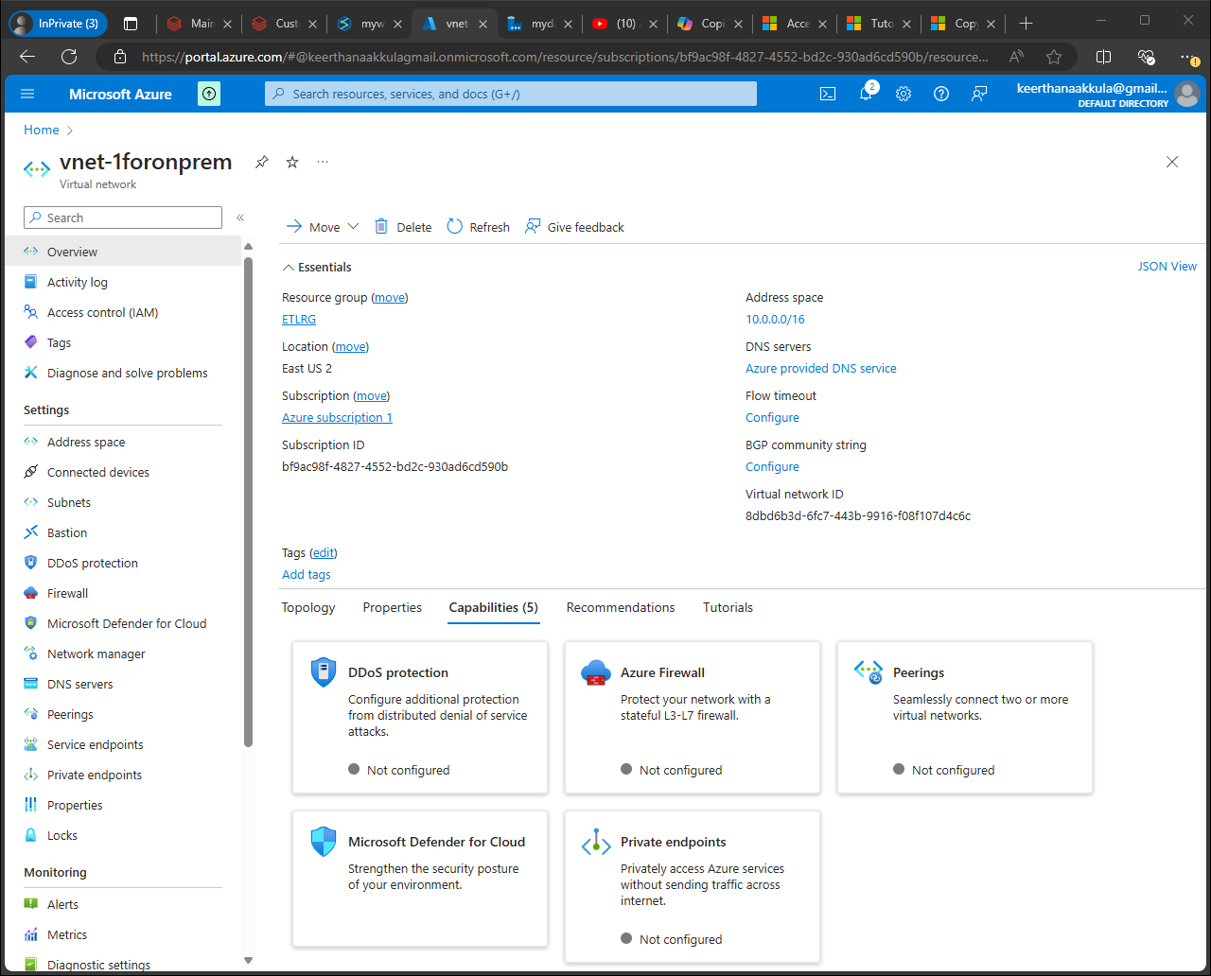

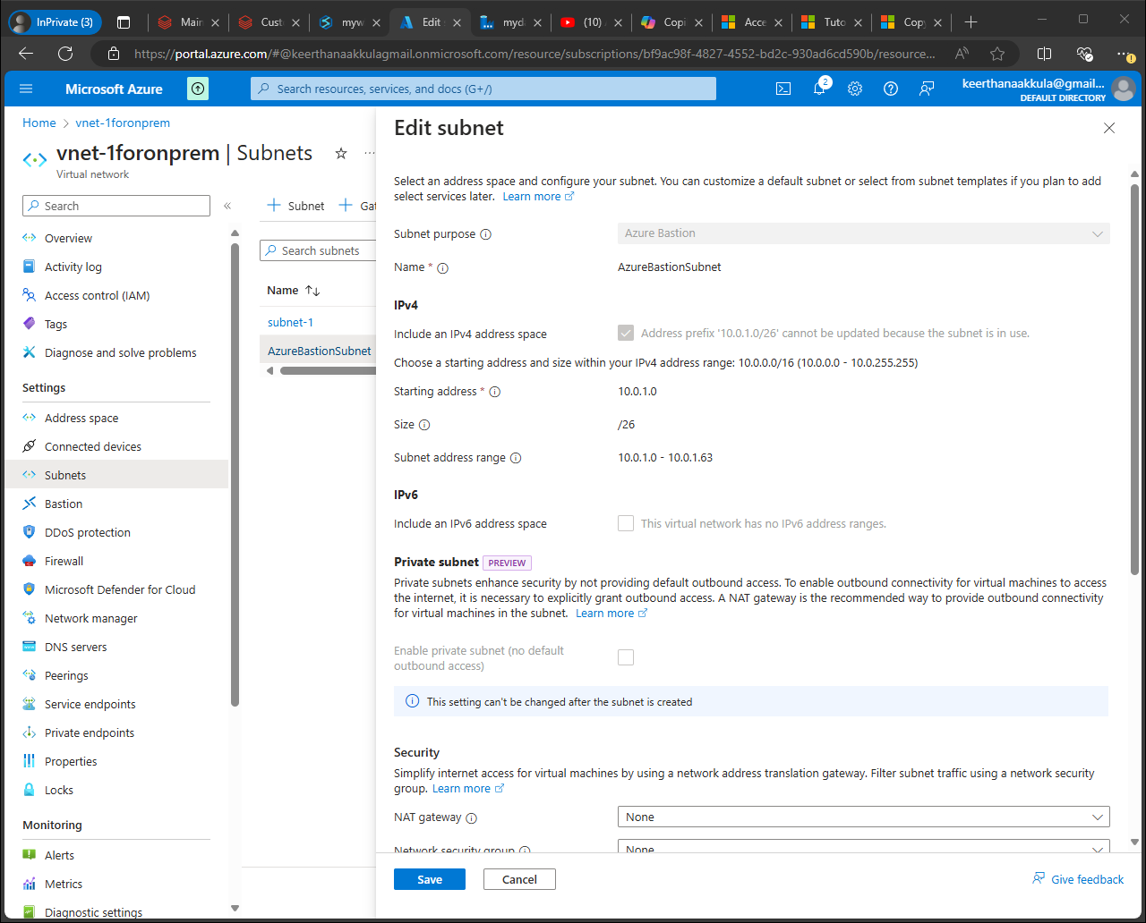

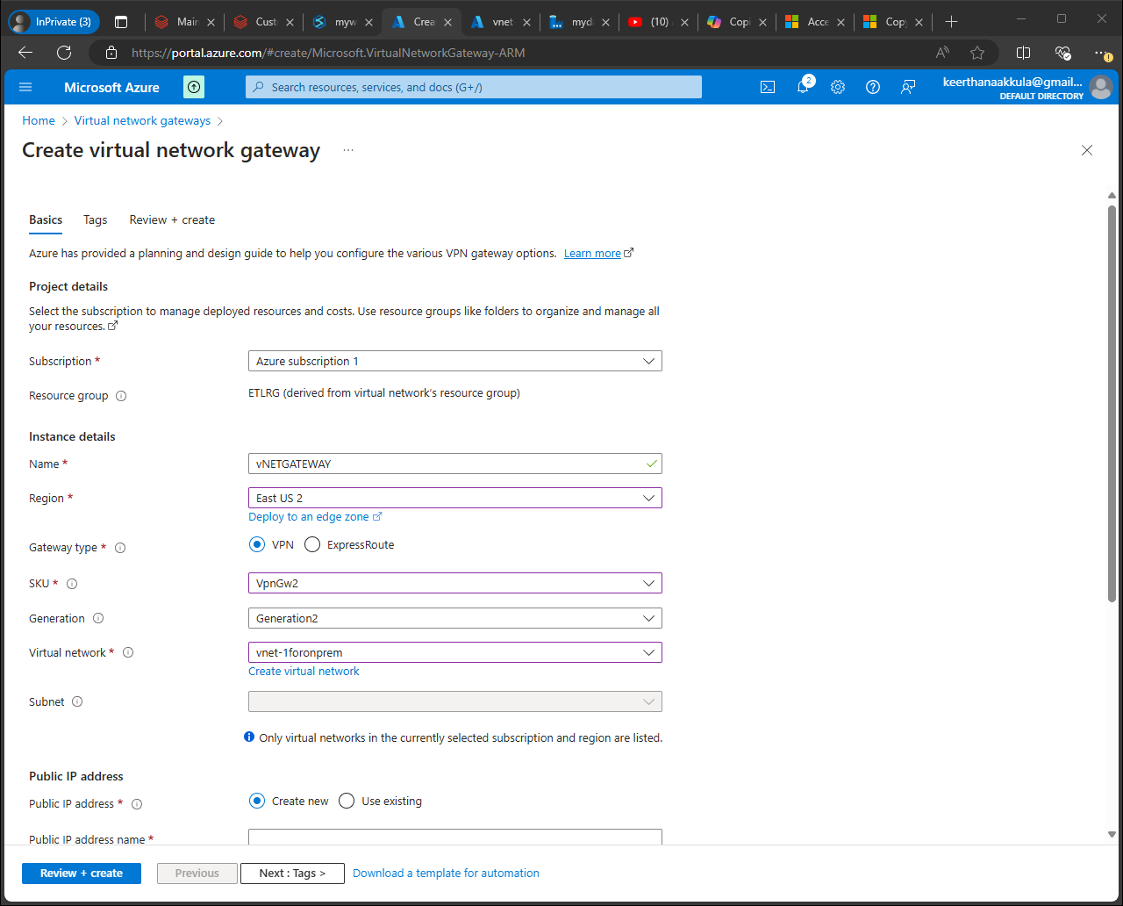

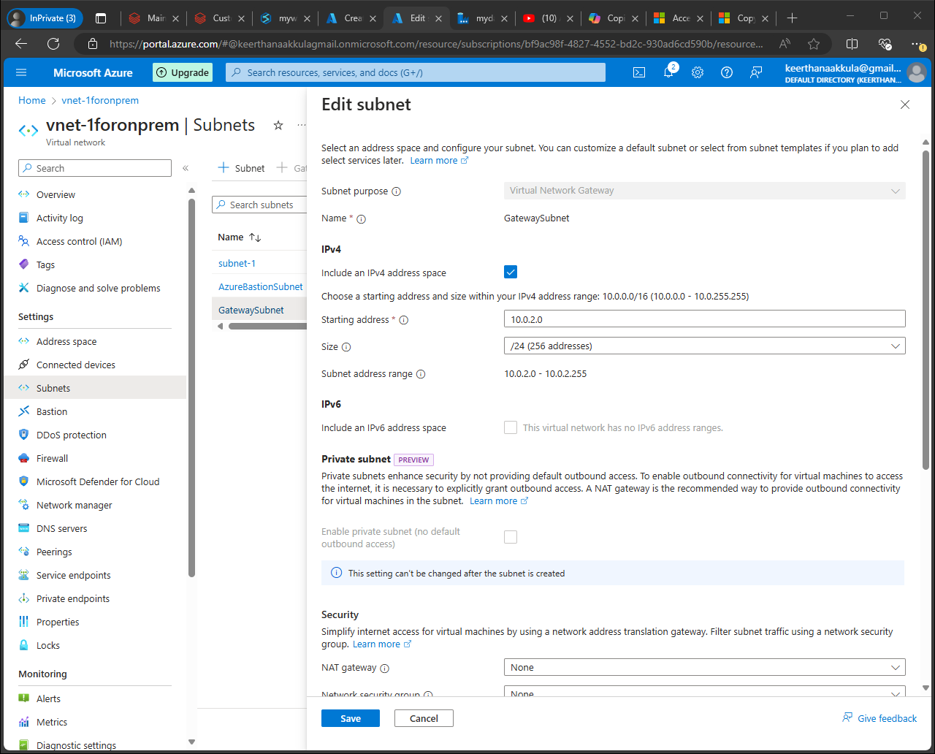

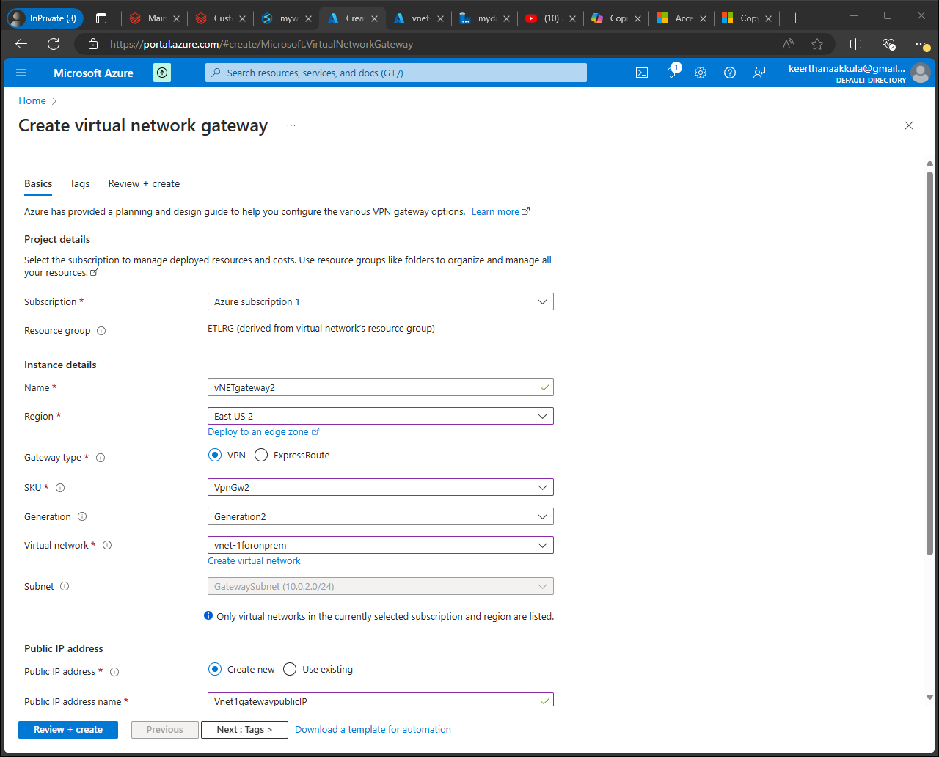

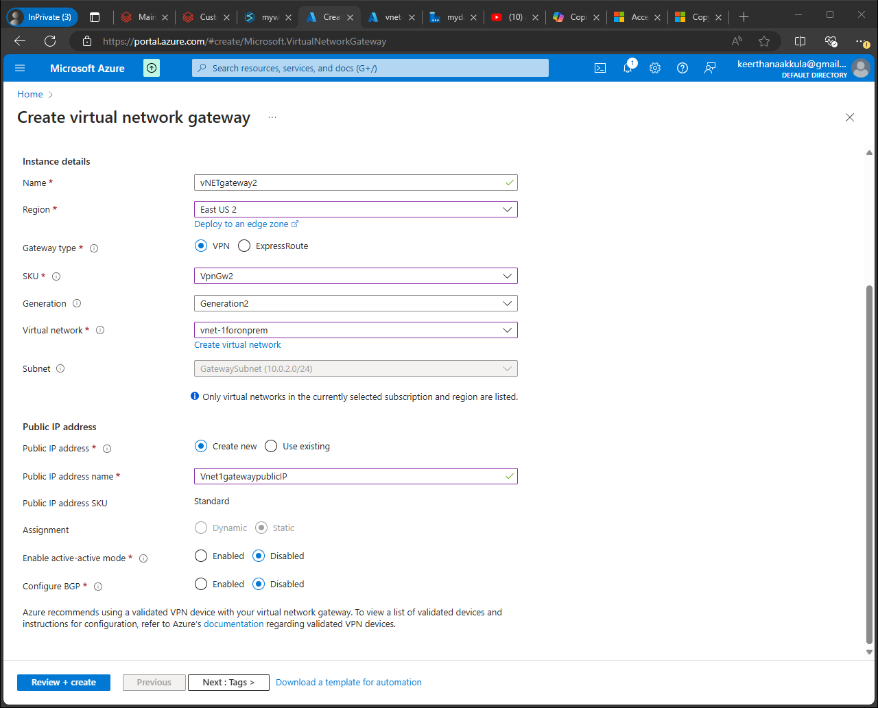

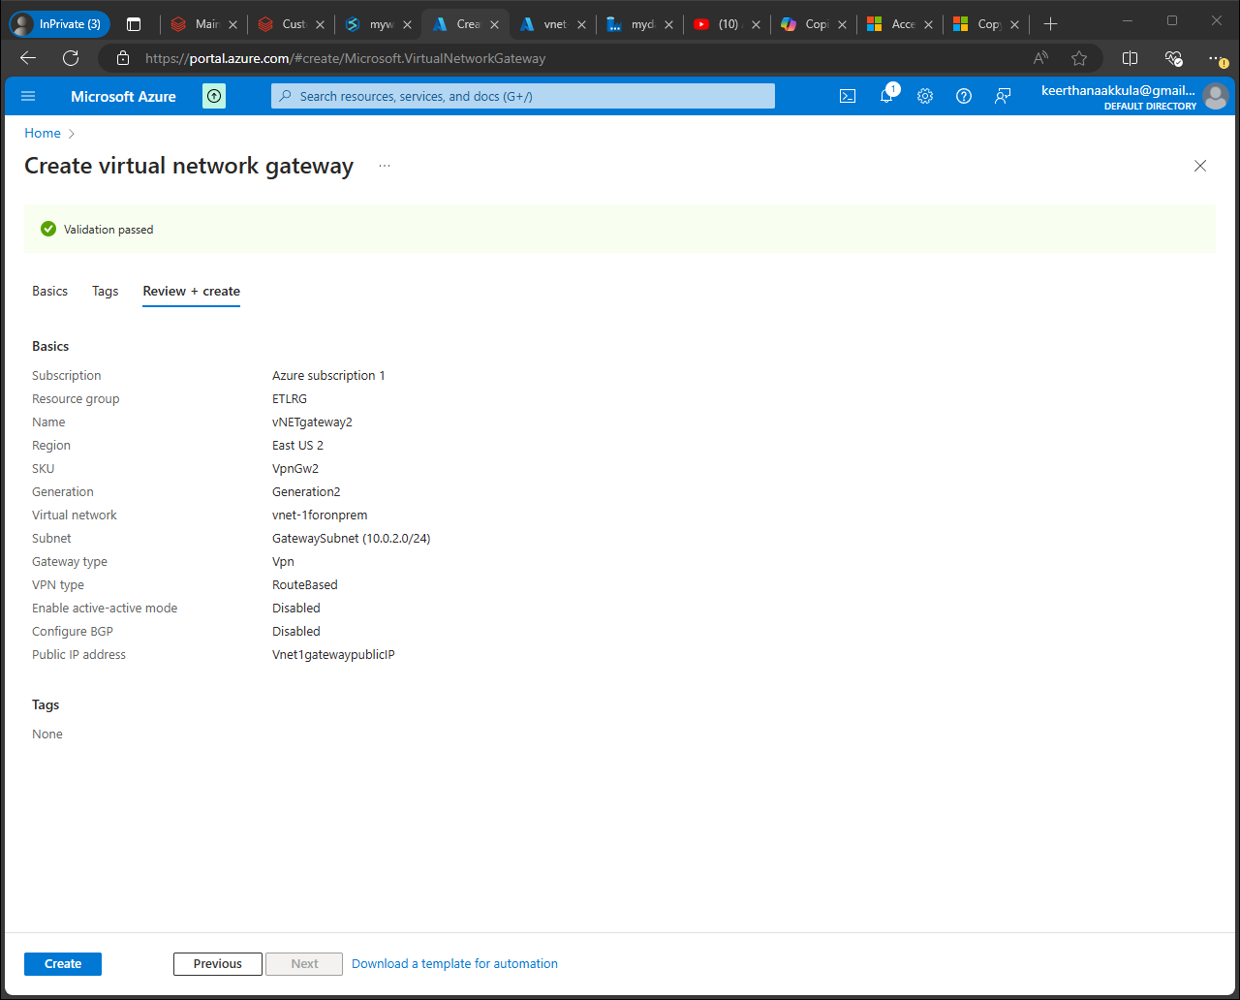

40.84.35.141

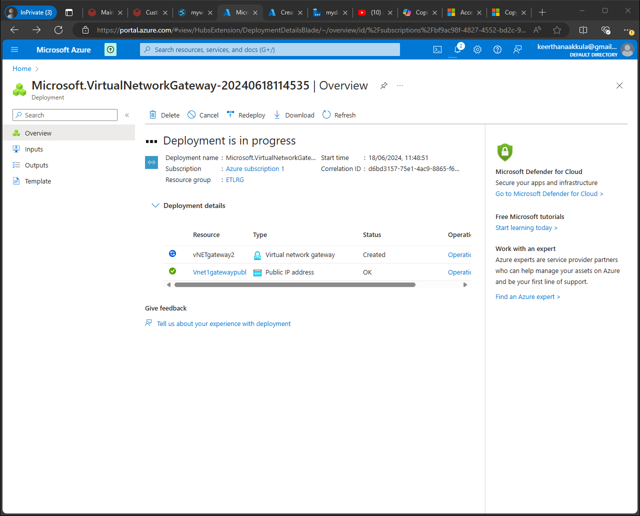

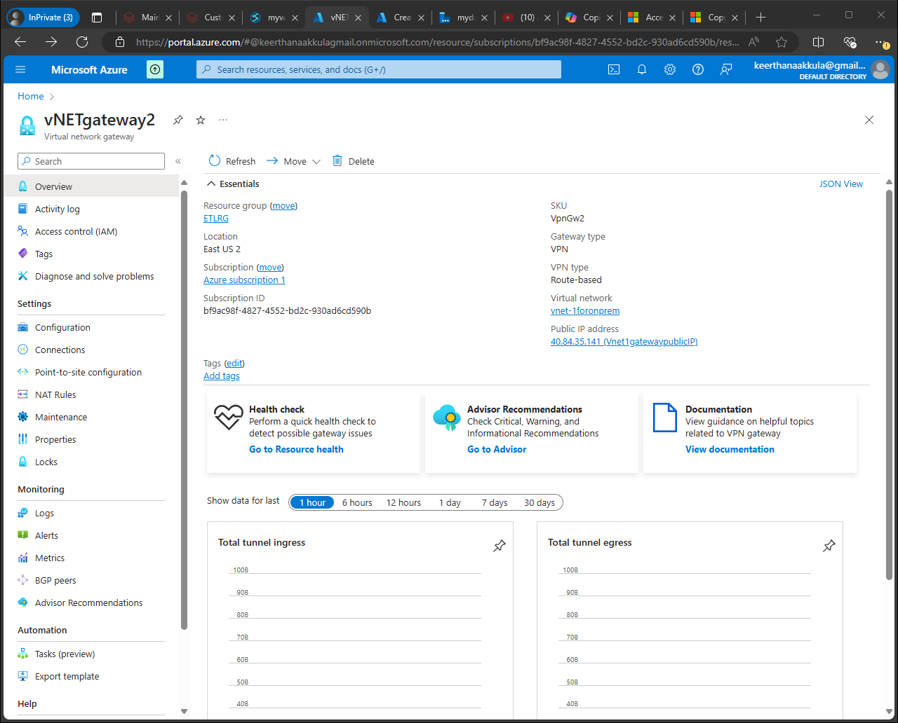

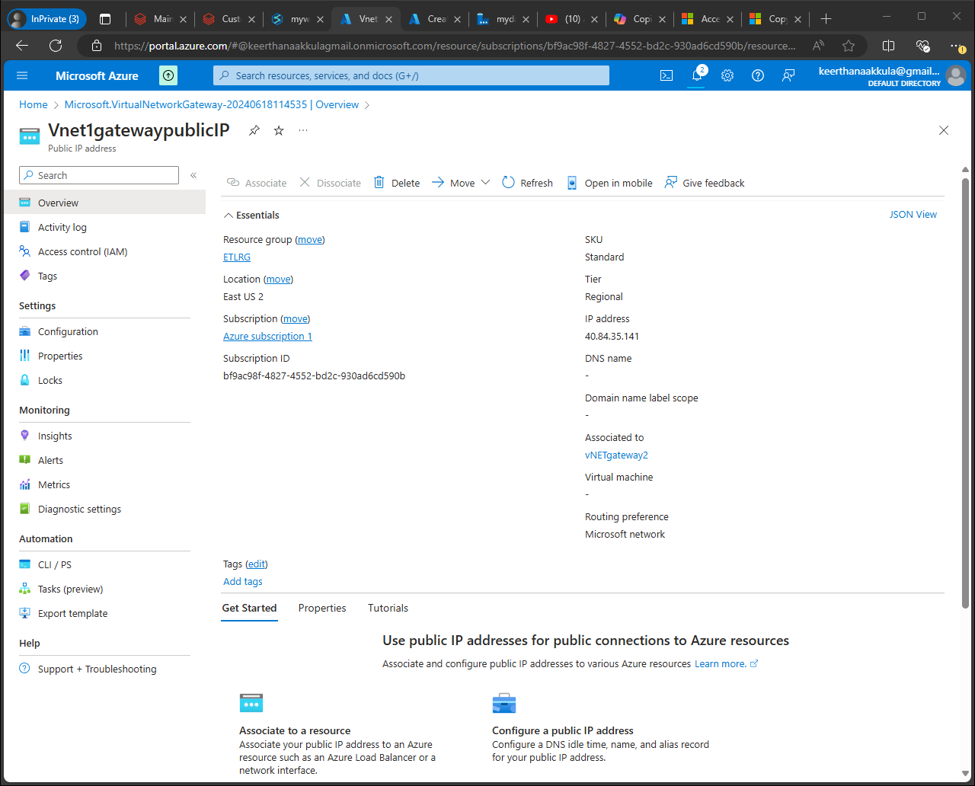

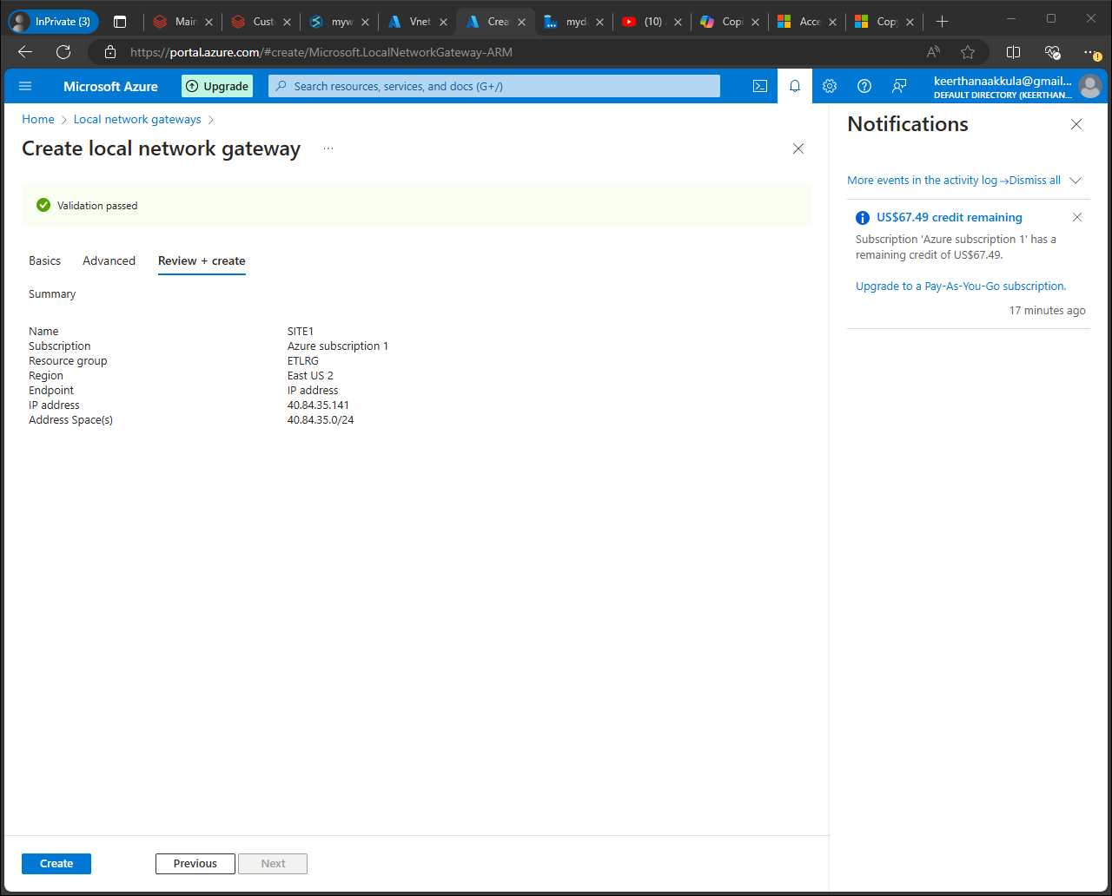

For Shared Key (PSK), enter: MySuperSecureKey12345!

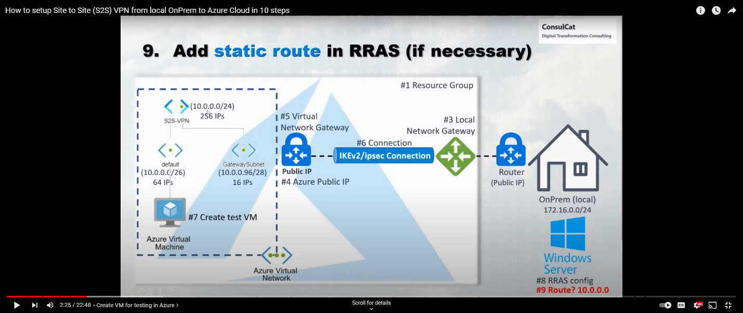

[How to setup Site to Site (S2S) VPN from local OnPrem to Azure Cloud in 10 steps (youtube.com)](https://www.youtube.com/watch?v=MorG47BTttU)

[Access on-premises SQL Server from Data Factory Managed VNet using Private Endpoint - Azure Data Factory | Microsoft Learn](https://learn.microsoft.com/en-us/azure/data-factory/tutorial-managed-virtual-network-on-premise-sql-server)

4 Advanced Considerations: Data Format Exploration: Experiment with different data formats (CSV vs. Parquet) and compare processing efficiency. Parquet offers better compression and faster query performance for analytical workloads.

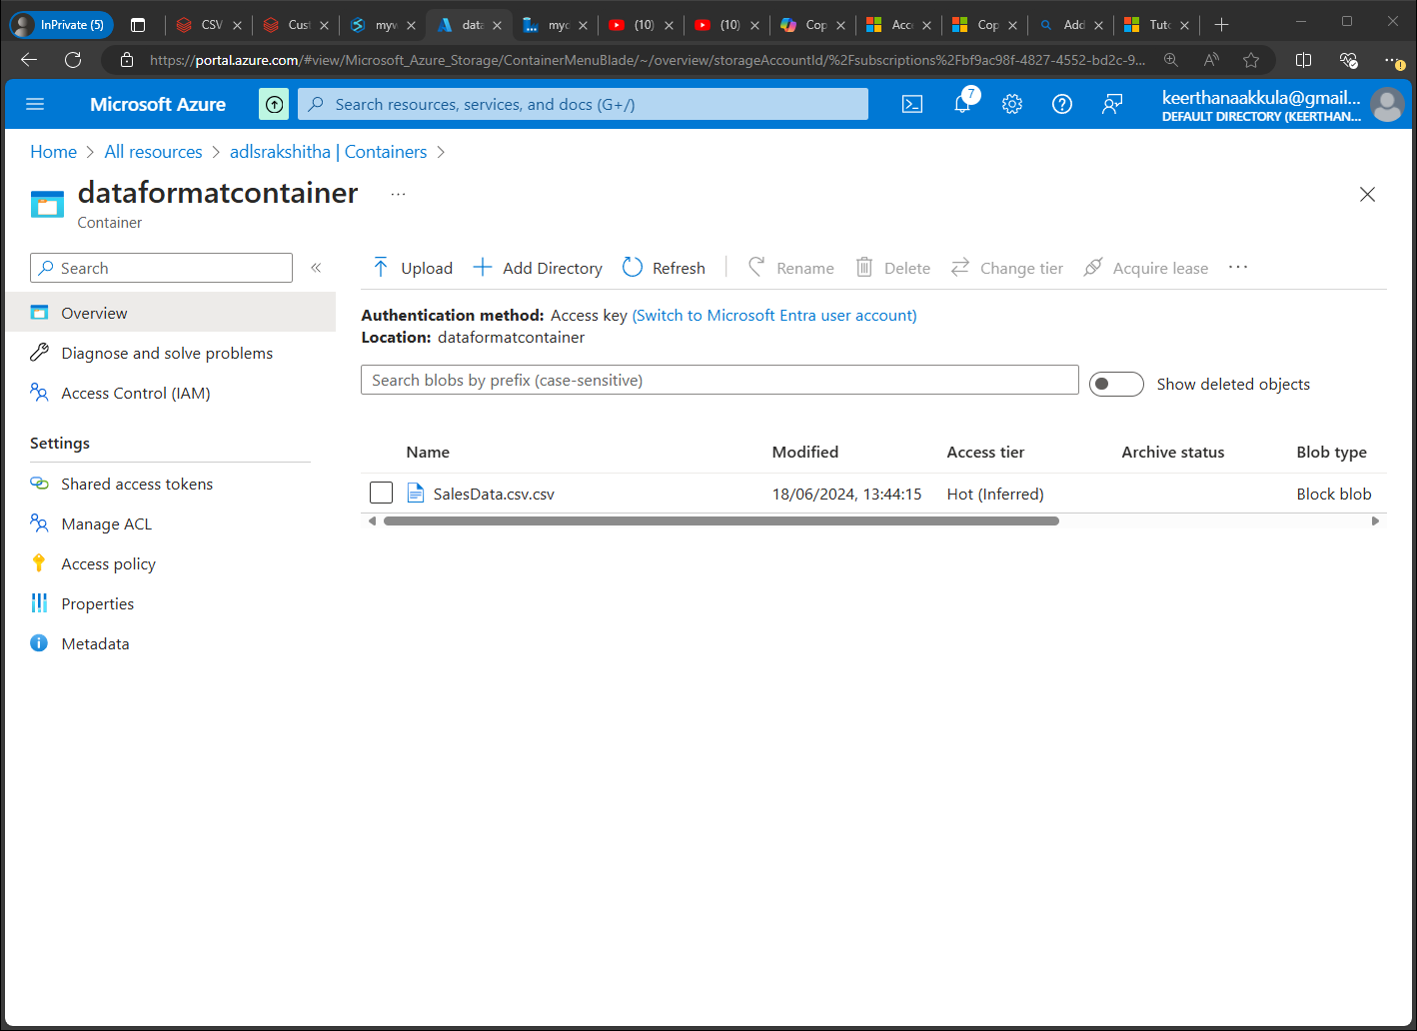

rakshithaSecretScope

The Medallion Architecture, also known as the Lakehouse Architecture, is a data management pattern that organizes data in layers to improve data quality, processing efficiency, and maintainability. This architecture typically involves three layers:

1. **Bronze (Raw Data) Layer**: Stores raw data in its original format.
2. **Silver (Refined Data) Layer**: Contains cleaned and processed data, ready for analytics.
3. **Gold (Serving) Layer**: Consists of highly refined data used for reporting and dashboards.
4. 